COP 2800
Assignment 6

Go Dolphins!!!
This assignment is a simulation of beer drinking football fans and the security guards that love them.
Design Requirements:
Class Beer – Tracks whether it is full or empty and has a getter. Also, has a drink method.
Class SixPack – Starts with an array of 6 beers, dispenses beers up to 6, and has a toString.
Class Person – Has a first and last name, getters, and a toString
Class NFLFan – Extends Person, drinks beers and keeps count, getter and toString
Class StadiumSecurity – Extends Person, chews out fans who’ve had more than 2 beers, getter and toString

Please title your java file Assignment6.java. Submitted files that do not compile will receive a grade of 0.

Next page – sample output and the driver used to generate it

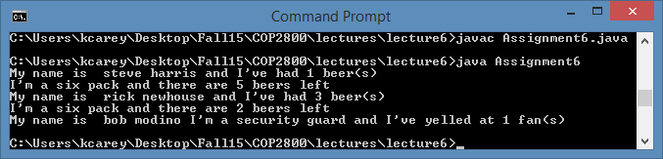

No output from the class definitions. All the output was done from this driver:

public class Assignment6 {
public static void main (String [] arg) {
SixPack sixPack = new SixPack();
NFLFan steve = new NFLFan("steve", "harris");
NFLFan rick = new NFLFan("rick", "newhouse");
StadiumSecurity bobTheSecurityGuard =
new StadiumSecurity("bob", "modino");

steve.drinkBeer (sixPack.getABeer());
System.out.println(steve);
System.out.println(sixPack);

rick.drinkBeer (sixPack.getABeer());
rick.drinkBeer (sixPack.getABeer());
rick.drinkBeer (sixPack.getABeer());
System.out.println(rick);
System.out.println(sixPack);

bobTheSecurityGuard.challengeBeerDrinker (steve);
bobTheSecurityGuard.challengeBeerDrinker (rick);
System.out.println(bobTheSecurityGuard);
}
}
Note: This is not the driver I will use to test your program. I will check for these implementation errors:
- A fan upping his beer count by drinking an empty beer
- A six pack that dispenses more than six beers
- A security guard yelling at a fan who is under the beer limit
- etc

